Declaration of Conformity (DoC)

We, Shenzhen Doke Electronic Co., LTD

801, Building3, 7th Industrial Zone, Yulv Community, Yutang Road, Guangming District, Shenzhen, China

Declare that the DoC is issued under our sole responsibility and belongs to the following product(s):

Product Type: | Tablet PC
Trademark： | Blackview
Model Number(s): | ZENO 5

(Name of product, type or model, batch or serial number)

System components:

PIFA Antenna
Bluetooth: 1dBi
2.4G WLAN: 1dBi
5.2G WLAN: 1dBi
5.8G WLAN: 1dBi
GSM 900: -1.10dBi; GSM 1800: 0.65dBi
WCDMA B1: 0.92dBi; WCDMA B8: -1.10dBi
LTE B1: 0.9dBi; LTE B3: 0.8dBi; LTE B7: 0.7dBi; LTE B8: -1.1dBi; LTE B20: -1.1dBi; ; LTE B28: -2dBi

Adapter:
Model: QZ-0180AEA00
Input: 100-240V~50/60Hz 0.5A
Output: DC 5.0V 3.0A 15.0W orDC 9.0V 2.0A 18.0W or DC12.0V 1.5A 18.0W
Manufacturer: Guangdong Quanzhi Technology Co., Ltd.
Rechargeable Li-ion Battery:
Model: U3067133PHVUTL
Rated Voltage: 3.85V
Charge Limit Voltage: 4.4V
Capacity: 8300mAh
Manufacturer: SHENZHE NUTILITY ENERGY CO., LTD.

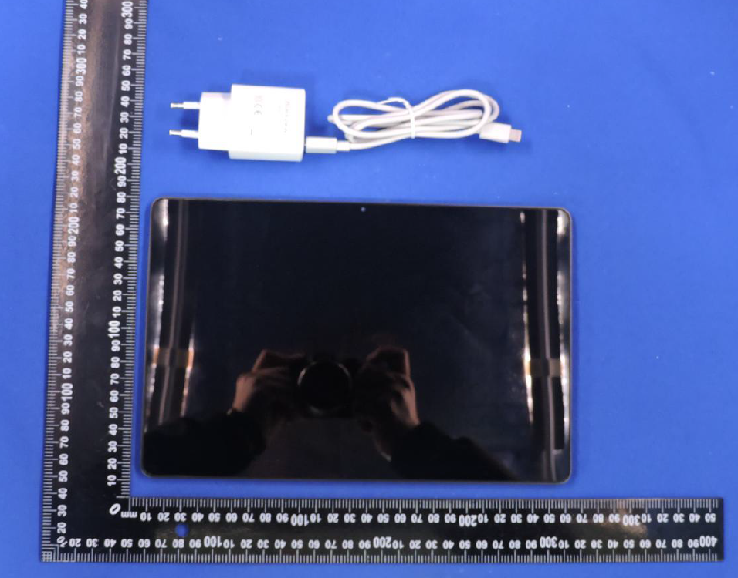

The object of the declaration described above is in conformity with the essential requirements of the relevant Union harmonization legislation: Radio Equipment Directive RED (2014/53/EU).
The following harmonized standards and technical specifications have been applied:

HEALTH & SAFETY (Art. 3(1)(a)):

EN IEC 62368-1:2020+A11:2020

EN 50566: 2017+A1:2023

EN IEC/IEEE 62209-1528:2021

EN 50663:2017

EN 62479:2010

EMC (Art. 3(1)(b)):

ETSI EN 301 489-1 V2.2.3 (2019-11)

ETSI EN 301 489-3 V2.3.2 (2023-01)

ETSI EN 301 489-17 V3.3.1 (2024-09)

ETSI EN 301 489-19 V2.2.1 (2022-09)

ETSI EN 301 489-52 V1.3.1 (2024-11)

EN 55032:2015+A11:2020

EN IEC 61000-3-2:2019+A2:2024

EN 61000-3-3:2013+A2:2021+AC:2022

EN 55035:2017+A11:2020

Radio Spectrum (Article 3.2):

ETSI EN 300 328 V2.2.2 (2019-07)
ETSI EN 301 893 V2.1.1 (2017-05)
ETSI EN 300 440 V2.2.1 (2018-07)
ETSI EN 303 413 V1.2.1 (2021-04)
ETSI EN 303 345-1 V1.1.1(2019-06)
ETSI EN 303 345-3 V1.1.1(2021-06)
ETSI EN 301 511 V12.5.1 (2017-03)
ETSI EN 301 908-1 V15.2.1 (2023-01)
ETSI EN 301 908-2 V13.1.1 (2020-06)
ETSI EN 301 908-13 V13.3.1 (2024-10)
The submitted samples of the above equipment has been tested and found to comply with the following European Directives:
RoHS Directive 2011/65/EU & (EU) 2015/863

NOTIFIEDBODY:

Name: DERYCOM CERTIFICATION SERVICES, INC.
Address:1100 FalconAvenueGlencoe,Mn55336 IdentificationNumber:3052
EU-type examination certificate number: JEC-96

RF Specification:

Function | Operation Frequency | Max RF output power:
BLE | 2402MHz–2480MHz | 2.85 dBm
BT(BR+EDR) | 2402MHz–2480MHz | 3.5 dBm
WIFI 802.11b/g/  n(HT20/40) | 802.11b/g/n(20MHz): 2412~2472MHz;  802.11n(40MHz):2422~2462MHz | 15.32dBm
Wi-Fi 5.2G(802.11a/n20/ac 20/  N40/ac40/ac80) | 802.11a/ n20/ac 20:5180MHz~5240MHz  802.11 n40/ac 40:5190MHz~5230MHz  802.11 ac 80:5210MHz | 14.23dBm
Wi-Fi 5.8G(802.11a/n20/ac 20/  N40/ac40/ac80) | 802.11a/ n20/ac20:5745MHz~5825MHz  802.11 n40/ac40:5755MHz~5795MHz  802.11 ac 80:57750MHz | 12.95dBm
GSM/GPRS 900 | TX(Uplink):880M‐915MHZ;  RX(Downlink):925M‐960MHZ | 33.21dBm
GSM/GPRS 1800 | TX(Uplink):1710M‐1785MHZ;  RX(Downlink):1805M‐1880MHZ | 29.73 dBm
WCDMA B1 | TX(Uplink):1920-1980MHz;  RX(Downlink):2110-2170MHz | 22.10 dBm
WCDMA B8 | TX(Uplink): 880-915MHz;  RX(Downlink):925-960MHz | 23.06dBm
LTE FDD B1 | TX(Uplink):1920-1980MHz;  RX(Downlink):2110-2170MHz | 22.53dBm
LTE FDD B3 | TX(Uplink) :1710-1785MHz;  RX(Downlink):1805-1880MHz | 23.83 dBm
LTE FDD B7 | TX(Uplink) :2500-2570MHz;  RX(Downlink):2620-2690MHz | 23.72 dBm
LTE FDD B8 | TX(Uplink): 880MHz to 915 MHz  RX(Downlink): 925 MHz to 960 MHz | 24.58dBm
LTE FDD B20 | TX(Uplink): 832MHz~862MHz;  RX(Downlink):791MHz~821MHz | 23.82 dBm
LTE FDD B28 | TX(Uplink): 703 MHz to 748MHz  RX(Downlink): 758 MHz to 803 MHz | 23.93dBm

Tests for SAR are conducted using standard operating positions with the device transmitting at its

highest certified power level in all tested frequency bands. The maximum SAR values tested on this device when used in its normal position when used closet other body (at a minimum distance of 0mm) are:

Max SAR Value(W/kg)  Limitis 2.0(W/kg) for10-g | 10-gBody | 0.863
Limitis 4.0(W/kg) for10-g | 10-gMemberDAS | 0.863

Technical file held by: Shenzhen Doke Electronic Co., LTD
801, Building3, 7th Industrial Zone, Yulv Community, Yutang Road, Guangming District, Shenzhen, China

Signed for and on behalf of: Shenzhen Doke Electronic Co., LTD
Name and Title:
Address: | 801, Building3, 7th Industrial Zone, Yulv Community, Yutang Road, Guangming District, Shenzhen, China


Signature of Authorized Person
2026-04-27

